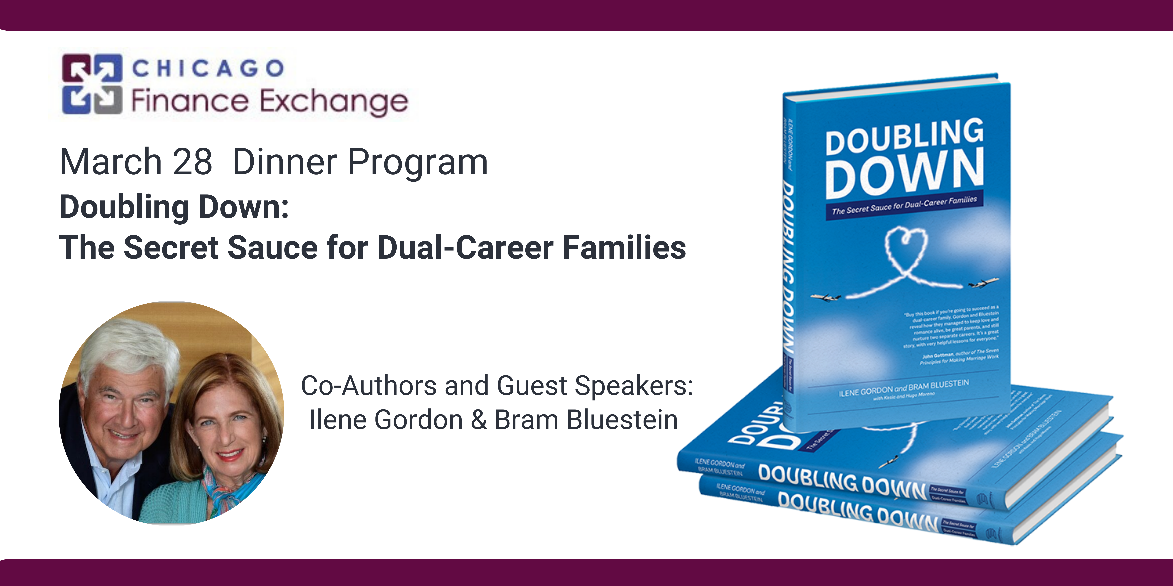
SPONSORSHIP OPPORTUNITIES

Premier Sponsor
Cost: $5,000
Eight registrations for this event (reserved table with priority seating)
Eight copies of the book Doubling Down: The Secret Sauce for Dual-Career Families
Opportunity to introduce the guest speakers
Corporate marketing materials placed at all tables
Corporate logo displayed on signage and on screen at the event
Corporate logo on all email communication for this event
Corporate logo on the CFE website and event page
Recognition from the podium at the event
Recognition on social media
Event Sponsor
Cost: $2,000
Four registrations for this event (reserved priority seating)
Corporate logo on the CFE website event page
Corporate logo displayed on screen at the event
Recognition from the podium at the event
Recognition on social media

Register online at www.chicagofinanceexchange.org or complete the information below.

Contact
Organization
Address
City, State & Zip
Phone & Email
Indicate Payment Method (CC, Check, Request Invoice
Please reply by returning this form via email to: dhypke@managementservices.org
Questions? Contact Deb Hypke at (312) 833-8782

