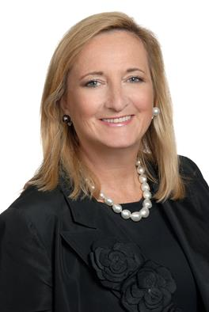

EILEEN A. KAMERICK
Eileen.Kamerick@gmail.com

Ms. Kamerick consults and lectures on corporate governance and compliance matters and is an NACD Board Leadership Fellow. She has served as CFO of such leading companies as BP Amoco Americas, Leo Burnett, Heidrick & Struggles, and Houlihan Lokey.

Ms. Kamerick began her career as a lawyer at the law firm of Skadden Arps and she holds a JD and an MBA, with honors, in Finance and International Business from the University of Chicago.

She is a member of the Board of Directors for Associated Banc-Corp, Hochschild Mining, plc, and 23 closed end Legg Mason mutual funds. She also serves on the Board of Directors for ACV Auctions, a Bain and Bessemer Ventures backed company that recently went public.

Ms. Kamerick previously served as an Independent Trustee for AIG Funds. She also served on the Board of Directors for ServiceMaster and IRI before both companies were purchased by private equity firms.

She qualifies as an SEC financial expert and chairs three audit committees and one corporate governance and sustainability committee. Ms. Kamerick also serves on the National Board of Directors of the Alzheimer’s Association where she chairs the investment subcommittee.

Ms. Kamerick is a lecturer at University of Chicago Law School, Georgetown University Law Center, and University of Iowa College of Law and for the NACD Battlefield to Boardroom board readiness program for flag officers. She recently served as a judge for the Investor Relations Magazine annual corporate governance awards.

