Lisa Wilhelm Haag, CFA
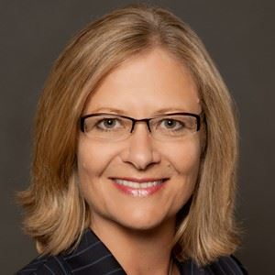

Lisa is an Independent Board Director for Fitch Ratings, a globally regulated, major credit rating agency & a Fitch Group subsidiary of Hearst Communications, Inc.; Board Director for Heartland Alliance, an anti-poverty nonprofit serving 85 programs globally with a $190M budget, 1,000+ employees, & 800 volunteers; prior Independent Board Trustee & Audit Chair for Merrill Lynch Insurance Group Variable Insurance Trust, a 25 mutual funds/variable annuities platform.
Lisa’s corporate experience includes, Director of Investment Strategy leading strategic/tactical investment approach and asset allocation for $50B+ in defined benefit assets and Director of Fixed Income & Currency overseeing external management of $20B+ fixed income assets and $5B in active currency overlays for The Boeing Company.

